For 14 people the testing and validation using the 2 files :-

1. Logistic regression

For both files minute one (concteration) : 10 right of 14

For both files minute two (Relax) : 8 right of 14

1. Voting regression

For both files minute one (concteration) : 9 right of 14

For both files minute two (Relax) : 9 right of 14

# positive (true, false) : calculation :

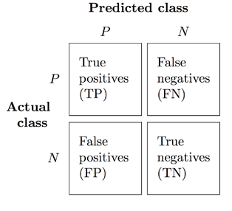

Results:-

1. Logistic regression

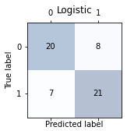

1. Voting regression

